Running head: SOVTECH FINAL PROJECT PROPOSAL

SovTech Final Project Proposal

Rachel, Faiza, Semab, Erica

Marymount University

**Table of Contents**

**Introduction.................................................................................................3**

**Purpose and People at Sovtech ..................................................................3**

**A South African Tradition .........................................................................5**

**Working Globally and Worldwide Locations.......................................................................................................5**

**A Sovtech Sales Liaison ..............................................................................4**

**Financially, Sovtech is the Cream of the Crop...............................................................................................................4**

**Employment..................................................................................................4**

**Technology Fueling the Company.......................................................................................................5**

**Current and Past Events..............................................................................5**

**Broadening the Horizon...............................................................................5**

**Conclusion ....................................................................................................5**

**References......................................................................................................6**

**Introduction**

SovTech is a custom software development company providing a complete software design and development service based in Blairgowrie, Gauteng, South Africa. SovTech delivers the best in class custom software solutions, elite software development teams and innovative cloud software to enterprise business across numerous industries. They believe new technologies are the lifeline of every business in the modern age and aim to connect businesses across all industries to innovative software, technological development, solutions and services, in a manner that’s faster, easier and better than ever before.

**Purpose and People at Sovtech**

Sovtech Is a trendy startup custom software development company born out of Silicon Valley and is now based in Johannesburg and Nairobi. that provides software design and development service. The company collaborates closely with our clients to create custom solutions that help achieve their business goals and optimize opportunities. Sovtech is made up of an expert team of elite engineers, designers, coders and industry specialists. The company’s purpose is to use the progressive technology they develop to apply it to Africa's problems. There are certain specifics the company values to achieve their goal. Smile, Adapt, Results, Tech, Innovate, #GoogleIt, #Partnership, #Sorted, #Worldclass, #Blitz and #GiveASh*t. Working with likable individuals with the idea to grow together as a company, change the world and find solutions to problems, and are not afraid to continue learning are the values at Sovtech.

Sovtech’s Chief Executive Officer is Gerald Neves. He is also a director at The Smacs Initiative; an online design and home store. Gerald went to St. Johns College from 2000 - 2005, University of Cape Town from 2007-2010, and International Business Development Institute from 2010-2012.Gerald also speaks English and Portuguese. One of the JavaScript developers of the company, Paula Eltringham has expressed her passion about Sovtech.

*“What made me really want to work for SovTech was the culture in general. Everyone that works for the company is very young and very passionate about tech. I play foosball with my CEO daily and go out with my Directors on the weekend. We don't just work together but we also are all friends, which makes going to work every day a fun experience. On top of that, I have always been interested in technology and because I had little work experience SovTech was a great starting point.”*

Sovtech is the perfect place for a young person to learn and grow. It is a thriving learning culture and encourages everyone to learn from each other. Sovtech prides itself on starting up in a developing country and producing world class applications which can compete in the global market and has a lot of impact. The company’s aim is to be the best custom software development company in the world.

**A South African Tradition**

Tradition is a way of passing on customs and beliefs down from the current generation onto the next. This was it can on forever South Africa’s culture is one of the many diverse cultures in the world. Some have given it the term “Rainbow Nation”. The country recognizes 11 official languages and recognizes 8 others. South African traditions are a blend of different customs performed by different ethnic groups. To name a few the Zulus are known as shield bearing warriors and for beadwork, weaving basketry and building grass huts. The Ndebele’s women are known for their abilities of decorating their houses with geometric patterns and designs. They pass this skill down to their daughters hereditarily and by teaching them. Their women stand out from others by wearing big neck rings are traditionally clothed material. In today's tradition most of the younger generation has moved to the city and are living a more westernized life.

**Working Globally and Worldwide Locations**

Since Sovtech is considered to be one of the best software developing companies in South Africa, it’s obvious that they’ve put forth much of their efforts to represent Africa, by showing that even though we are still developing we are one of the global leaders in technology, as well as make their mark globally. Currently, there are four global offices the first one, which is the main one is located in Joburg, South Africa, whereas the other three are located in Kenya,

the United Kingdom, and the United States. This provides Sovtech with a wide range of opportunities to work with lots of major companies, for example, Sovtech has worked with Canon, ADT, standard Bank, Deloitte, and many others. Also, as or right now they have over 400 clients around the world and they plan on expanding this number in the years to come. However, one barrier in which may prevent them from spreading further on the map is the fact that there are a sparse amount of offices located globally and the fact that the root of the company comes from a developing company may make it difficult for the company to stand out, especially in comparison to a huge number of companies located in the United States or China, which are the two most economically and globally prominent countries in the world.

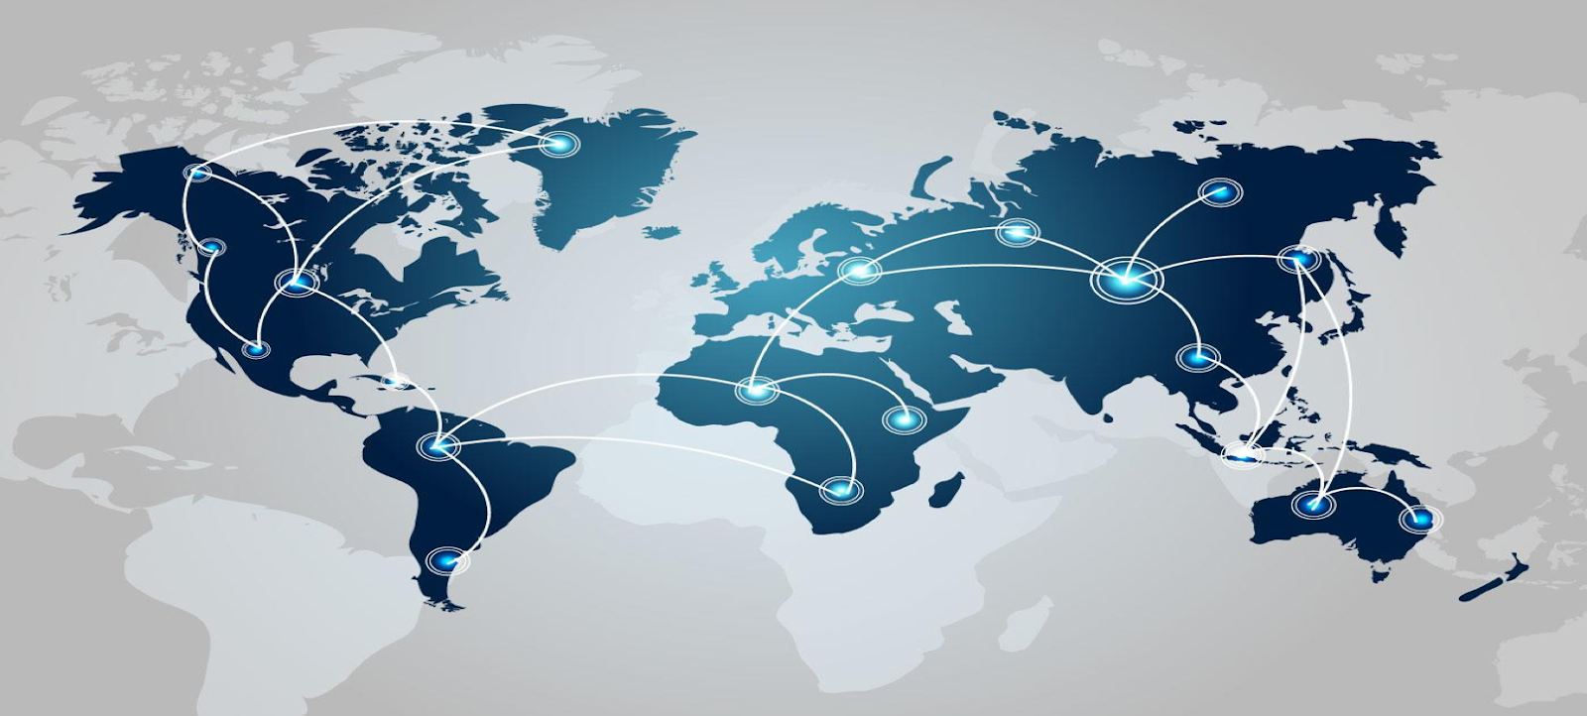

Figure 1:Map of Offices and Clients Located Globally

**A Sovtech Sales Liaison**

Below you will find a screenshot of the communication we started with Paula Eltringham. Paula is a sales liaison and lives in Cape Town, South Africa where Sovtech is headquartered. She is the first point of contact between clients and the organization. Based on my discussion with her I was able to learn that Paula is proud of her studies in technology and influencing as a social subject. For her Honors Thesis she was able to incorporate Instagram influencing and technology into a social space and look at it from a different perspective.

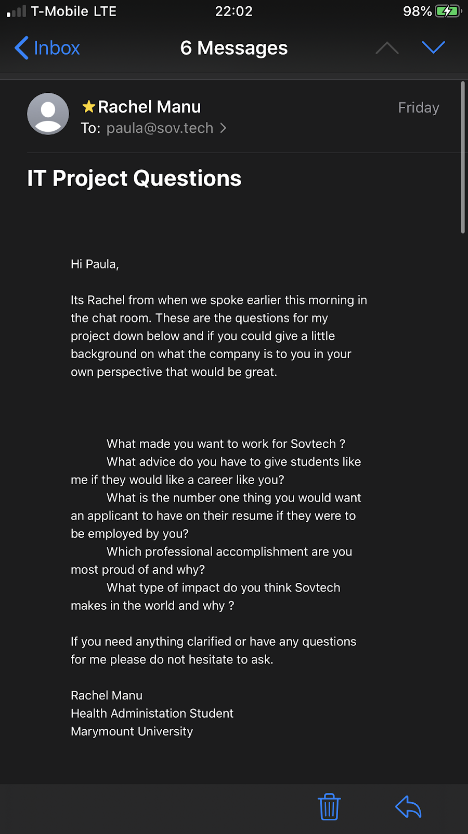

**Finance**

Sovtech is currently in a stable and sufficient financial standing, especially due to the fact that it is working with over 1000 projects with more than 400 companies. It is even working with major companies such as discovery, Deloitte, Canon, and Standard bank, which have made billions over the years; Due to this they are getting a significant amount of investment back through these key clients, so much to the point where their revenue is estimated to be around 2-5 million dollars (PR Newswire, 2019), which in comparison to other software developing companies in South Africa, ranks it pretty high. Therefore, with this revenue, they will continue to expand their company by continuing to implement more high-quality resources and gather a diligent an educated team of experts for each project .

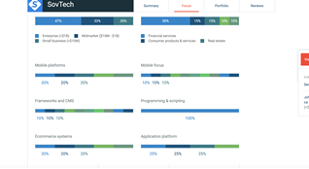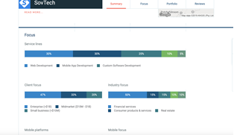

Text BoxText Box

**Employment**

According to Ms. Paula Eltringham, working for SovTech is an exhilarating experience. As much as the company appreciates and values education and experience, it put personal culture as a top priority. Alongside personality appreciation, SovTech is a company whose workers are young and agile, therefore extremely passionate and open-minded. For example, Ms. Eltringham regularly enjoys social activities with those higher up in the company, such as the directors’ and even the CEO. According to Glassdoor.com, SovTech is primarily Afro-centric with a diverse employee makeup and offers its employees continuous development opportunities. (Glassdoor, 2019)

According to the Etischool who has worked with SovTech, the company has been “extremely efficient” and “the team is friendly, helpful, and knowledgeable”. Managing Director Melissa Garvey states that she has been “very impressed with SovTech on a global level, having worked with many varied projects with dev teams around the world…The level of detail and design excellence they provided was very impressive. SovTech’s approach is one of professionalism, efficiency, expertise, and deep consideration for each project”. (SovTech, 2019)

Many of the positions at SovTech have to do with software engineering, such as JavaScript developing. (SovTech, 2019) Many of these jobs are located throughout South Africa, not just in Johannesburg where SovTech is headquartered. Most of the jobs require experience of about 1-3 years but it is emphasized that time doesn’t always go hand-in-hand with ability. Teams at SovTech are small, generally about 5 people, making them more personal, therefore more efficient. SovTech also offers its employees to work from the comfort of their own home whenever they please, just as long as communication with team members is effective.

**Technology Fueling the Company**

SovTech uses a variety to advanced technologies to make their products, a few of them include-

• Block chain Development: Due to its growing “implementation across global economies” and “significant change in progression in business processes” (SovTech, 2019)

• Artificial Intelligence: AI has significantly enhanced SovTech by implementing chat bots, email spam filters, and security surveillance. (SovTech, 2019) Such AI technology eliminates the need for workers to d a specific job so that their bright minds may be used elsewhere within the company.

• Machine Learning: A form of AI which allows machines to learn from data rather than having to be constantly reprogrammed. Such operation systems allow machines to automate with precision and accurateness. (SovTech, 2019)

• Augmented Reality: Stimulated and enhanced versions of reality that amplifies the user experience and allows the company to create otherwise impossible scenarios for client satisfaction. (SovTech, 2019)

• Virtual Reality: Differing from AR, Virtual reality transforms 2D views into interactive 3D experiences. SovTech uses this innovative technology to improve their products and to make a deep and personal connection with their clients. (SovTech, 2019)

**3 New Articles/Events:**

<https://sov.tech/sovtech-hackathon-2019/>

Impact: This article is discussing an event that Sovtech hosted recently where they gather a variety of IT experts, this can range from computer programmers to graphic designers(and more) and it allows them to create any software or applications without any restrictions, therefore they can generate new ideas and express their creativity. This is significant because this allows others to familiarize themselves with the company, therefore allow them to expand globally as well as allow them to bring in more ideas and innovations into the company.

<https://mybroadband.co.za/news/industrynews/281199-sovtech-launches-africas-biggest-blockchain-software-lab.html>

Impact: This article relates back to what we learned in class about block chaining, where it is essentially a chain of data/records, also called cryptography, and these records list transactions, also called cryptocurrency. It mainly talks about how Sovtech is now considered to be one of Africas largest blockchain labs and has the most extensive network of blockchain developers in all of Africa. This is important because it differentiates Sovtech from other software developing companies in Africa, which will in return give it a high ranking, and it proves the companies credibility, which can be appealing to future clients.

<https://sov.tech/women-in-stem-award-sponsor/>

Impact: This article goes on to talk about how Sovtech recently sponsored the “Best Women in STEM” award at the MTN Business App of the Year Awards. The two businesses that won were LocTransie and My Pregnancy Journey and this is significant because Sovtech is clearly trying to make an effort toward pushing young women to gain an interest in the STEM field, especially since the number of women pursuing the STEM field is declining rapidly. (There are also more articles they’ve done on this where they interviewed a woman named Daisy in the STEM field in order to gain her opinion and expertise on this matter:<https://sov.tech/women-in-it-daisy/>)

**Broadening the Horizon-**

As of now, SovTech really does have most of the new technology that is essential for tech startups to be successful in today’s advanced world. Further expansion is what seems to be the next vital step for SovTech to achieve further prosperity. Based in the developing continent of Africa, SovTech strives to produce world class applications and become a global leader in technology. (SovTech, 2019) I think once the company is recognized even further across the international market, SovTech should work towards expansion into other developing countries in order to boost their economy’s and technological understandings as well.

**Conclusion**

In conclusion, we learned that we need to start looking past the technology and companies we are so familiar with and start making an effort to research and understand other companies and innovations going on around the work because these companies and new technological innovation are beginning to make a big impact on our future and because we tend to focus on the bigger, more common, companies we then forget or rather neglect the foreign ones. Especially when we come from an economic and globally prominent country, such as the United States, it's very easy to only look towards major companies and technological innovation located near us. However, in the end, these companies outside the U.S. are also making a significant amount of progress and they bring a lot of promise to the technological field. SovTech was a great example to teach us this because it showed us that even though it is located in a developing country and is foreign to many of us, it still managed to extend and make its mark globally as well as create an exceptional amount of projects and software that work to fuel such high-end companies too which we are all familiar with. Not to mention that the company is putting so much effort towards sparking interest and trying to engage people in the IT field by hosting events and posting blogs, therefore showing that companies in other parts of the world, such as SovTech, also do make an impact.

**Works Cited**

# Bibliography

Clutch . (2019, April 24). *Sovtech:Business Software. Sorted*. From Clutch : <https://clutch.co/profile/sovtech>

PR Newswire. (2019, October 31). *TODAQ adds new global partners with close of first $5M investment round*. From Cision PR Newswire: <https://www.prnewswire.com/in/news-releases/todaq-adds-new-global-partners-with-close-of-first-5m-investment-round-892287254.html>

Glassdoor. (2019, September 27). *Working at SovTech*. Retrieved from <https://www.glassdoor.com/Overview/Working-at-SovTech-EI_IE2198028.11,18.htm>

SovTech. (2019). *About Us: SovTech*. Retrieved from <https://sov.tech/about-us/>

SovTech. (2019). *Careers Sovtech*. Retrieved from <https://sov.tech/careers/>

SovTech. (2019). *Clients: What Our Customers Say SovTech*. Retrieved from <https://sov.tech/clients/>

SovTech. (2019). *Development Technologies: SovTech*. Retrieved from <https://sov.tech/development-technologies/>

SovTech (2018, July 19). *Technology and the Economy.SovTech Insights.* Retrieved from<https://medium.com/sovtech-insights/technology-and-the-economy-811a61c2d3a4>

Miaschi, John. (2018, September 21). *South African Culture, Customs, and Traditions.* Retrieved from https://www.worldatlas.com/articles/south-african-culture-customs-and-traditions.html

Show Me (2006, November 06). *South African Culture.* Retrieved from <https://showme.co.za/facts-about-south-africa/south-african-culture/south-african-culture/>